*Instructions: Press File then Make a Copy to make an editable copy of this document in your Google Drive. You can also download as a .doc or .pdf. (No need to press the “Request Edit Access” button.) Thanks! - The GT Team*

**GIVINGTUESDAY**

**GETTING READY FOR GIVINGTUESDAY WORKBOOK**

A Step By Step Guide to Building a Successful Campaign

@givingtuesday [](http://facebook.com/givingtuesday)[](http://twitter.com/givingtuesday)[](http://instagram.com/givingtuesday) [](mailto:info@givingtuesday.org)

**Ready to inspire generosity across your community? We’re here to help.**

## EVERYDAY, THE SOCIAL SECTOR IS ON THE FRONT LINES, BUILDING STRONGER, HEALTHIER, SMARTER, FAIRER COMMUNITIES. THE SECTOR NEEDS NEW APPROACHES TO KEEP UP WITH THE NEED - AND THE DIGITAL WORLD. GIVINGTUESDAY IS A DAY TO TEST, LEARN, ENGAGE, AND FUNDRAISE.

### 

**GivingTuesday is a global giving movement with local impact**

GivingTuesday is an inclusive community of millions of givers, with activity in every country on every continent. We celebrate and uplift grassroots generosity, and generosity as a universally held value. Around the world, across diverse giving cultures, our network of local leaders in more than 70 countries and hundreds of communities innovate, collaborate, and inspire collective generosity as a way to build the world they want to live in.

It inspires people to take collective action to improve their communities, give back in better, smarter ways to the charities and causes they believe in, and help create a better world. GivingTuesday demonstrates how every act of generosity counts, and that they mean even more when we give together.

Get ready!

In this workbook, you'll tap into the collective experience of GivingTuesday leaders to learn how to:

* Plan your campaign and recruit a team
* Tell your story so that it inspires support
* Create timelines to organize your planning

# Table of Contents

* Introduction
* Think like an event
* Using this workbook
* Set your campaign goal
* Create a work plan
* Build a campaign brand
* Develop a campaign narrative
* Gather inspiring visuals
* Make an inspiring ask
* Organize your campaign team
* Identify Campaign Ambassadors
* Tech Check - Delight your Donors
* Plan Communications Strategy
* We’re here to help.

# 

|  |
| --- |
| Follow Along **Check out the Video Companion Guide**  [Click here](https://vimeo.com/givingtuesday/planningacampaign) to join Jamie McDonald, GivingTuesday’s Chief Strategy Officer as she walks through how to create a successful 2020 campaign. The video has captions in English and Spanish. |

# Approach It Like an Event

## How do you shift the tone of your GivingTuesday campaign from obligation to opportunity? Make it joyful. Try new things. Invite new people. Celebrate the change you’re creating in the world.

When done well, GivingTuesday doesn't feel like another fundraising campaign. We call it GivingTuesday - not fundraising Tuesday - for a reason. It's a day to inspire generosity in all forms, a day for people to generously share whatever they can, whether it is their time, skills, voice, or money.

And if you think about it more like an event, your supporters and potential supporters will feel it too. And, like a well-planned event, these are a few parallels to consider:

* A unifying theme - or goal - creates excitement and engagement, and a framework for decisions (You won't decorate for a St. Patrick's day party with sombreros and pinatas!).
* It's more fun with old and new friends
* Games and activities can make a big difference
* Sharing memories - stories, pictures - afterwards keeps the good feeling going, and builds interest and commitment for next year.

(Photo: Georgia Gives, December 2019)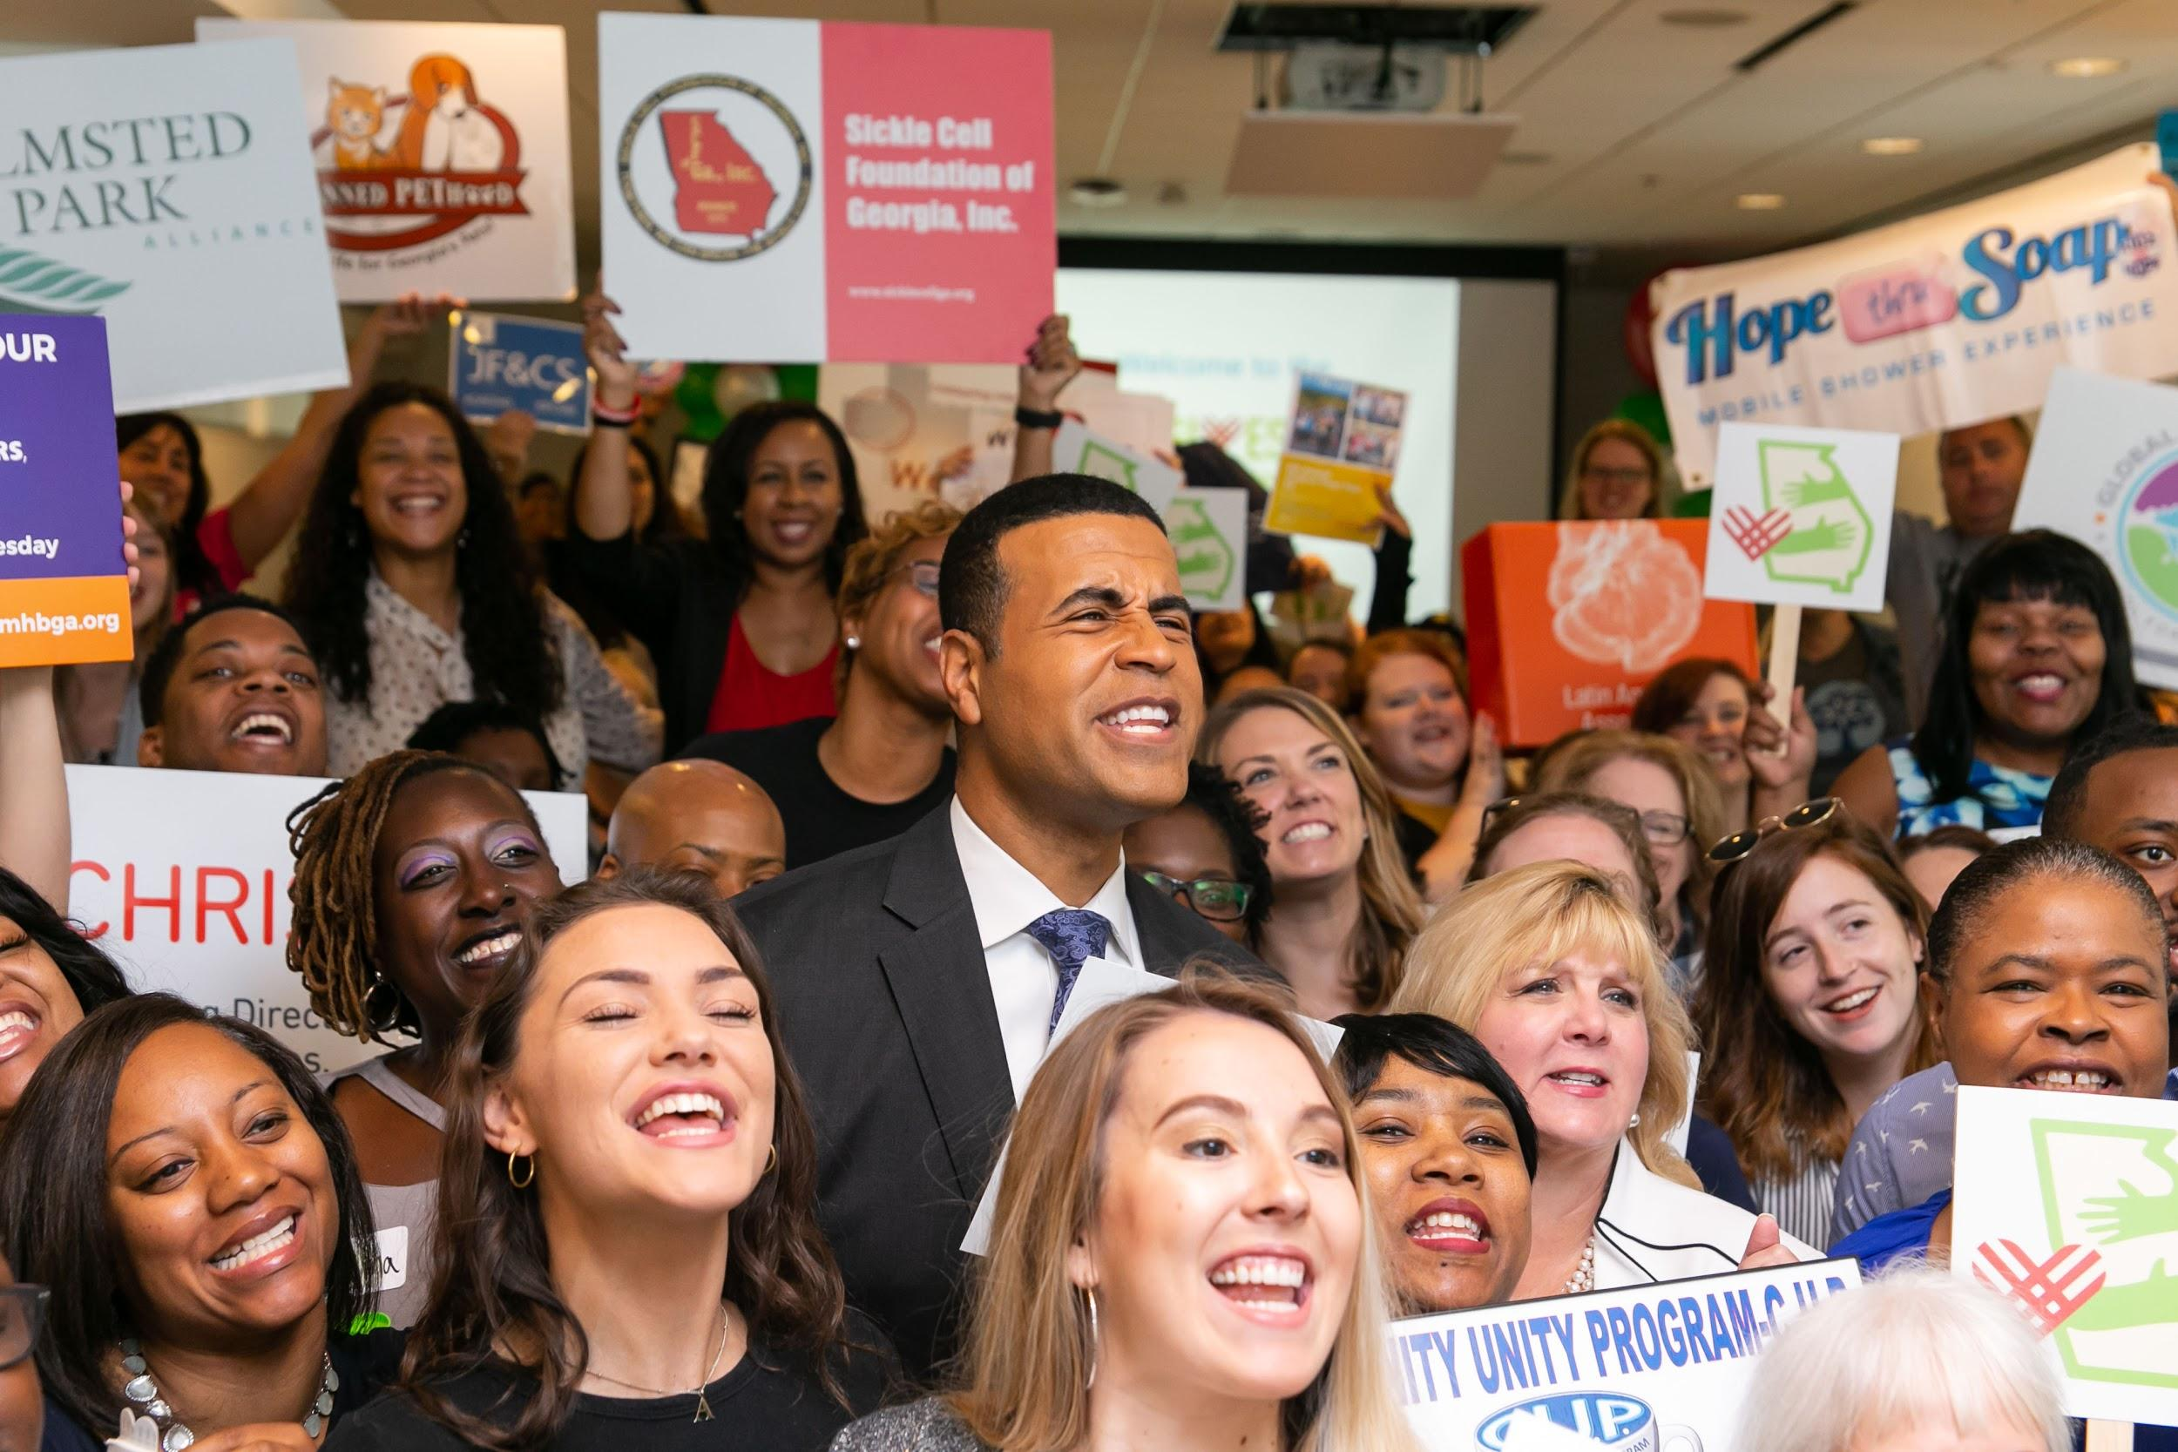

# Set your campaign goal

Your campaign goal serves as the campaign framework. Your goal should reflect your team's priorities. It's a great time to experiment with new strategies.

Set a GivingTuesday goal that is ambitious enough that your team will be motivated to achieve it.

Goals can be about a lot more than money. Here are some possibilities.

|  |  |  |
| --- | --- | --- |
| **Potential Goals** | | |
| Dollars | Donors | New Donors |
| Young Donors | Monthly Donors | Event Attendees |
| Participation | Collaborations | Social Followers |
| Volunteers | Activity Attendance | Thank yous |

|  |
| --- |
| **Write down some ideas for campaign goals here.**  What goal?  How many?  What event? |

# Set an activity timeline and meeting schedule

## Planning will keep your team aligned, your campaign organized for maximum impact, and momentum high.

|  |  |  |
| --- | --- | --- |
| **Action** | **By When?** | **Done?** |
| Determine team members |  |  |
| Set a kickoff meeting date |  |  |
| Agree on goal |  |  |
| Divide team into task groups |  |  |
| Create campaign brand |  |  |
| Build communications timeline |  |  |
| Recruit ambassadors |  |  |
| Recruit merchants/ small businesses |  |  |
| Reach out to longtime donors for matching funds |  |  |
| Assemble campaign stories and create outreach |  |  |
| Consider event or activity for supporters |  |  |
| Plan day-of “Zoom HQ” for your team + possibly a public facing version of that |  |  |
| Plan thanking and stewardship approach |  |  |

# Organize your campaign team.

A great campaign will inspire lots of folks to jump on board. Organize your team so that everyone involved knows what's expected and feels great about participating. Make a list of the people you hope to include in your campaign. When they say yes, check them off.

|  |
| --- |
| Staff/ Board |

|  |
| --- |
| Givers/ Volunteers |

|  |
| --- |
| Amplifiers |

|  |
| --- |
| Community partners (small businesses, PR, marketing) |

# Build a campaign brand for GivingTuesday

### Make GivingTuesday your own! Design a brand-name, logo, tagline - that will unify your campaign and elevate your marketing.

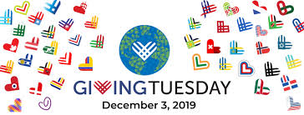

**Name**

Write down some ideas for a campaign name

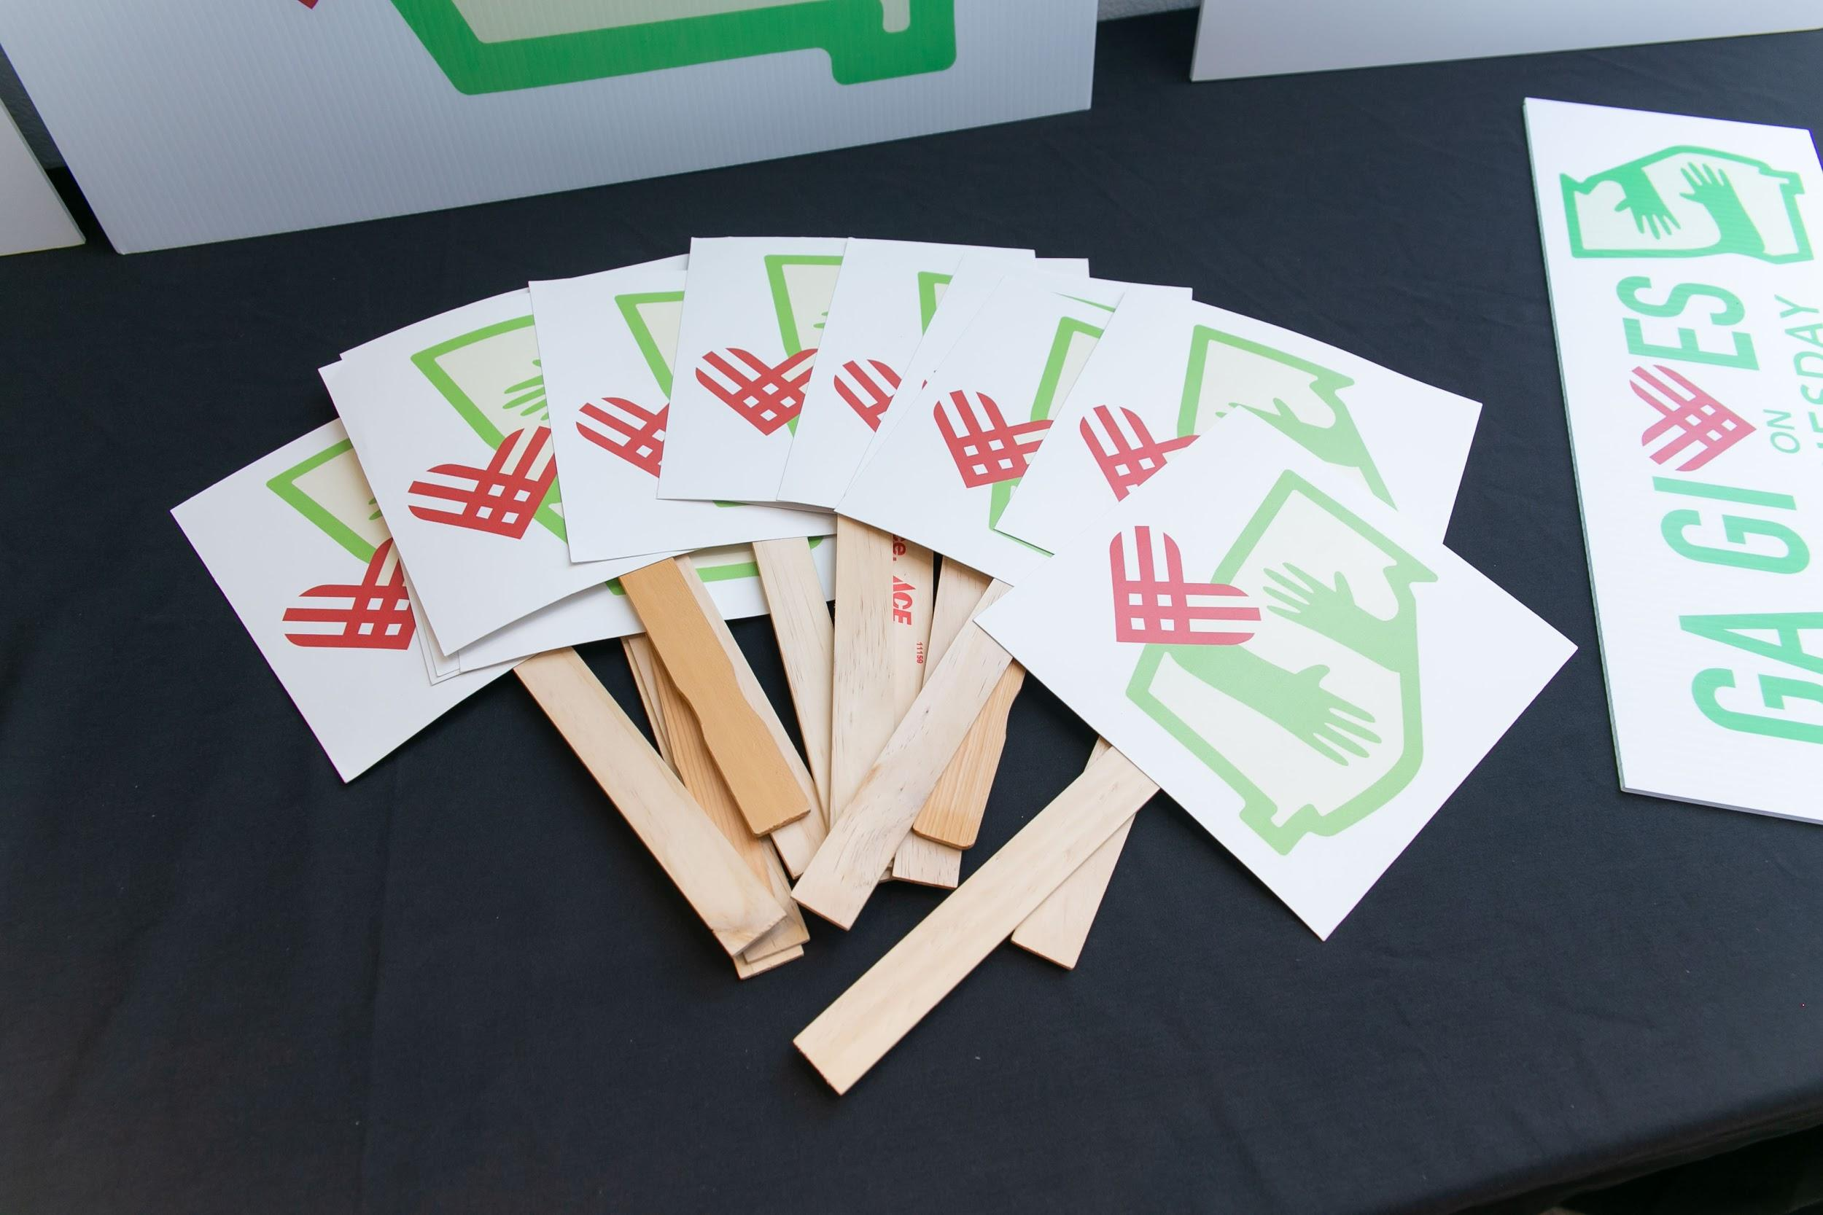

**Visuals**

Write down ideas for brand visuals



**Taglines**

Write down ideas for a campaign tagline

# Develop Campaign Narrative

## Narrative Checklist

* Specific program, project, or type of giving
* Iconic story of client, staff person, volunteer
* Supporting data
* Incorporate matching challenge
* Tie to year-end appeal

|  |
| --- |
| Story Idea 1 |

|  |
| --- |
| Story Idea 2 |

|  |
| --- |
| Story Idea 3 |

# Gather inspiring, authentic visual assets

Visual assets are at the heart of great communications. The logo, color palette, photos, and videos will provide the personality for the campaign and the authentic connection to your work. They don’t have to be perfect! 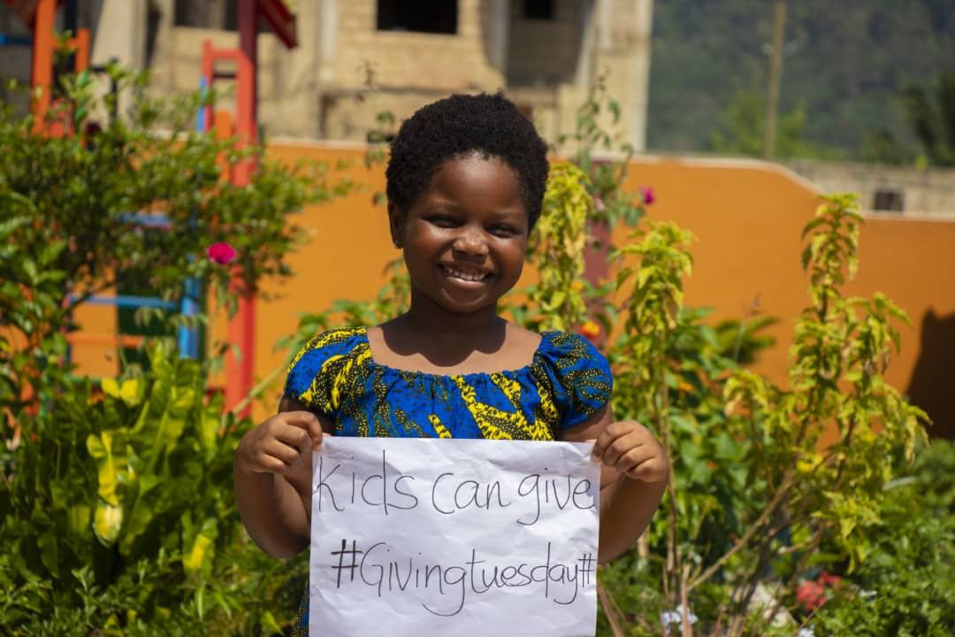

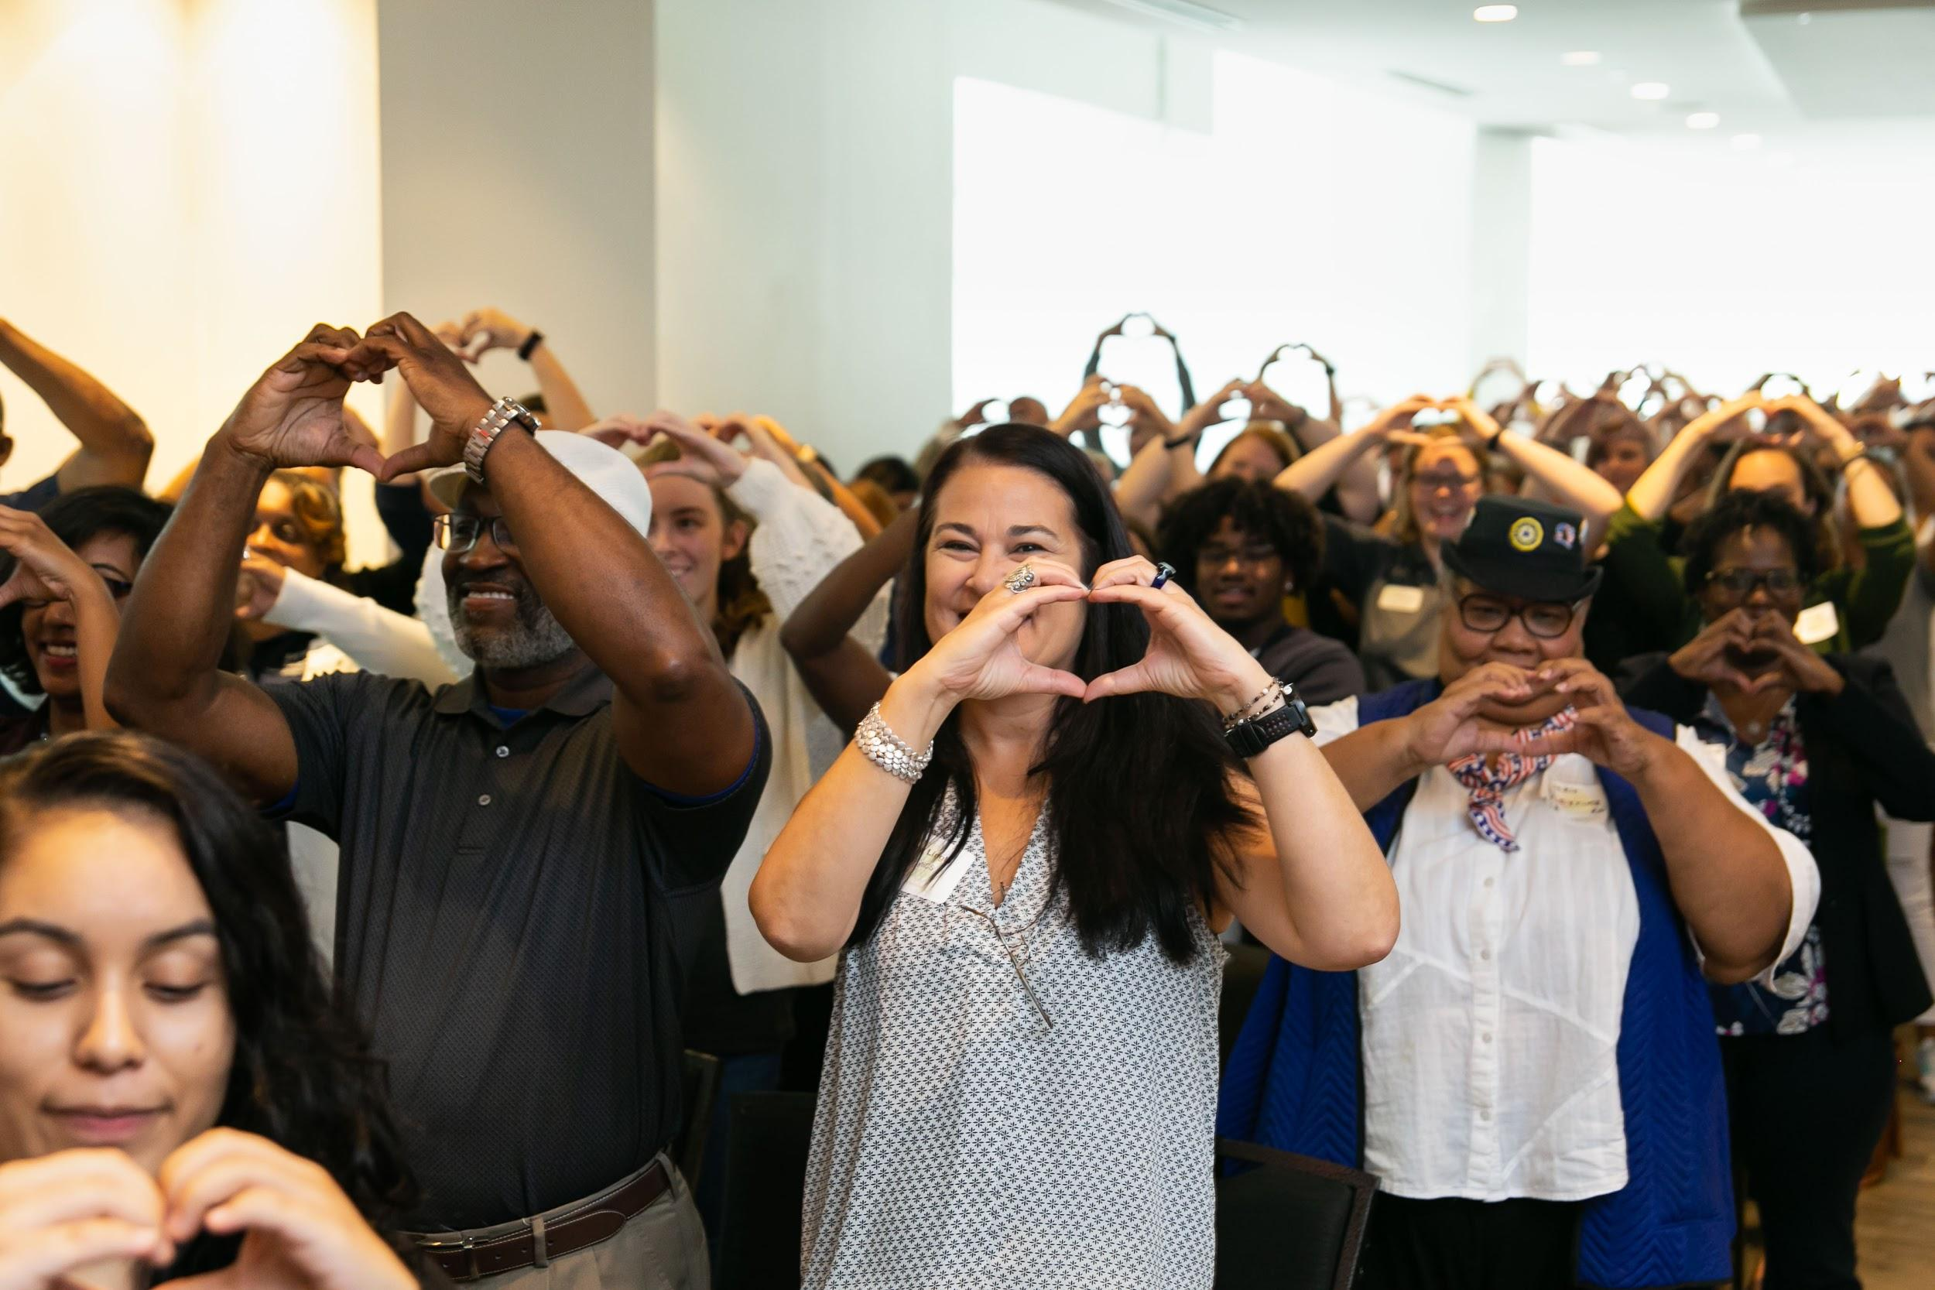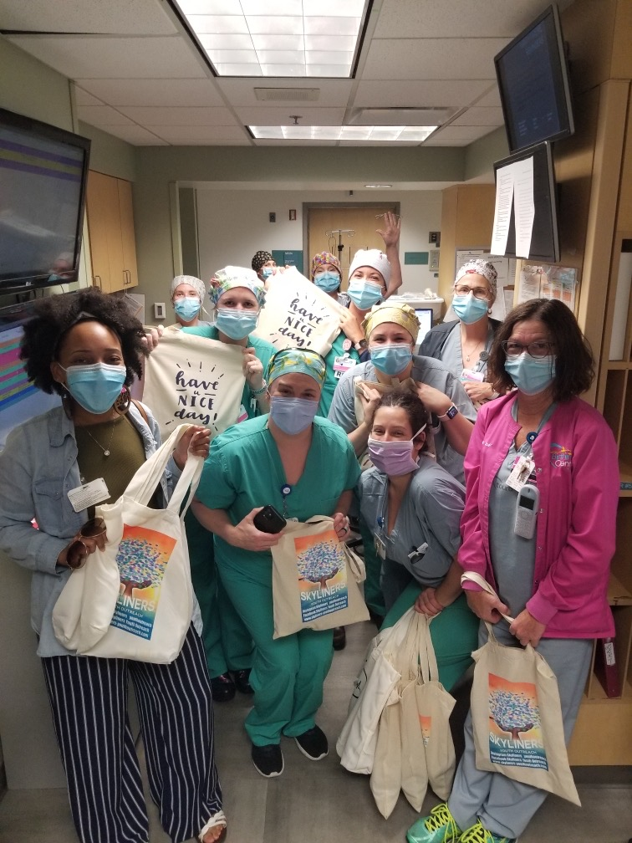

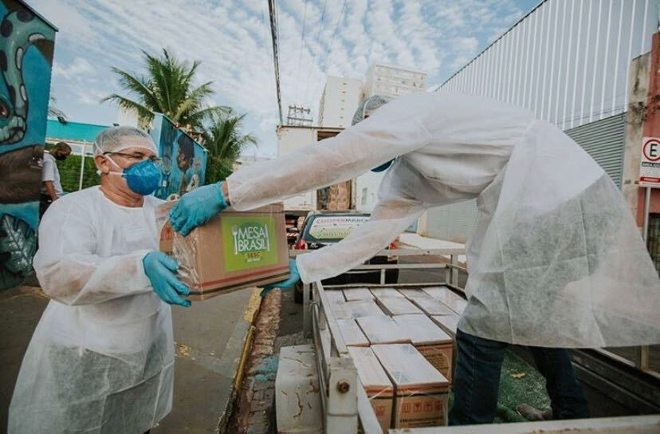

# Make an inspiring ask.

|  |  |
| --- | --- |
| Use the belief statement + You statement + Opportunity statement to pull a compelling call to action together. | Example: School that is raising funds to build a food pantry for students. Campaign will begin with a story of a student who was hungry. Then…  **Belief statement:** We believe that no student should have to choose between food and learning.  **You statement:** You can help us stock the pantry so that no CCBC student has to make the choice/ goes hungry.  **Opportunity statement:** Are you with us? |

|  |
| --- |
| Belief statement ideas |

|  |
| --- |
| You statement ideas |

|  |
| --- |
| Opportunity statement ideas |

# Identify Campaign Ambassadors.

### Campaign ambassadors believe in you and are big, credible voices that can amplify your campaign reach.

1. Identify ambassadors representing different communities of supporters
2. Engage ambassadors by setting aside a day to reach out and then hosting an ambassador kickoff
3. Resource ambassadors with engaging, easy-to-share content on a consistent schedule.

|  |  |
| --- | --- |
| **Staff and Board** | **Civic Leaders** |
| **Donors/ volunteers** | **Celebs/ athletes /microinfluencers** |

Who will be responsible for creating content and communicating with ambassadors?

# Do a tech check!

## Make sure that your tech delights your donors.



*Pro-tip: Go through your donors' experience on computer, tablet and phone. Start with email/social, click to website, make an online gift, and review the thank yous. Would your donors be delighted by the experience?*

*Note any fixes you need to make in the boxes below.*

Website, marketing, and donation processing should be reviewed and optimized for GivingTuesday. All should be simple, intuitive, and welcoming.



#### Website





#### Online Giving





#### Marketing and Outreach, Social Channels



# Spur participation with challenges and matching funds

### Contests, challenges, matching funds and other “gamification” are fun, engaging and make a big difference on GivingTuesday.

|  |
| --- |
| Matching Funds: Identify generous donors who can provide funds to spur generosity and progress toward campaign goals. Ask them to consider giving their year-end gift early to support challenges and spur participation. List here: |

|  |
| --- |
| Challenges and contests create energy and excitement. List challenge and contest ideas here: |

## Plan a robust marketing and communications strategy

Develop a plan to build excitement for your campaign. Consider mail, email, social media, and events. Create exciting, original content and communicate consistently through all of your outreach channels and to your campaign ambassadors.

The plan should be designed around your goals and brand so that all elements of your outreach reinforce each other.

Your marketing can start months before GivingTuesday. [Here’s a 6 week timeline to get you started with your communications plans.](https://drive.google.com/file/d/1NLDNDgZ1XXKCQ26HKTg1eudGRVgJQ8NH/view?usp=sharing)

#### 

Other Resources + Tools for a Successful GivingTuesday

Be sure to check the [resource hub at GivingTuesday.org](https://www.givingtuesday.org/organizations#block--additional-resources) - new tools are added all the time! We also invite you to join the [GivingTuesday Learning Lab](https://www.facebook.com/groups/GivingTuesdayNonprofitLearningLab) on Facebook and collaborate with organizations from all over the world.

#### 

#### 

|  |
| --- |
| We’re here to help.Connect with us!givingtuesday.org@givingtuesday |

#### 